**Name : Andraus Ashref Fahim Milk**

**Group : 2**

**Section : 10**

**B.N : 3**

**Topic : Artificial intelligence**

**Application Brief :**

I chose this topic as I see the it is very important now in our life. AndArtificial intelligence makes it possible for machines to learn from experience, adjust to new inputs and perform human-like tasks. Most AI examples that you hear about today from chess playing computers to self driving cars rely heavily on deep learning . Using these technologies, computers can be trained to accomplish specific tasks by processing large amounts of data and recognizing patterns in the data.

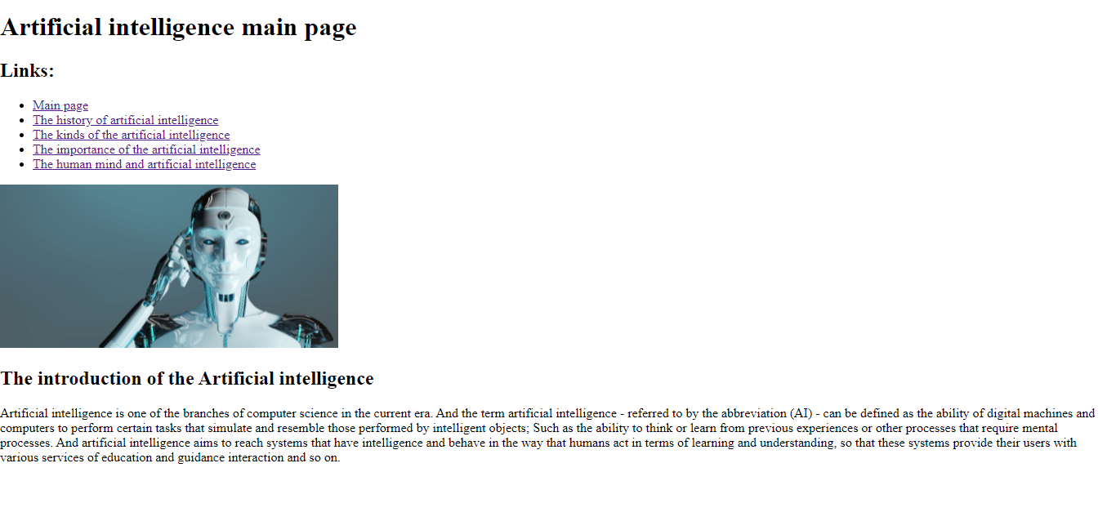

And this code is

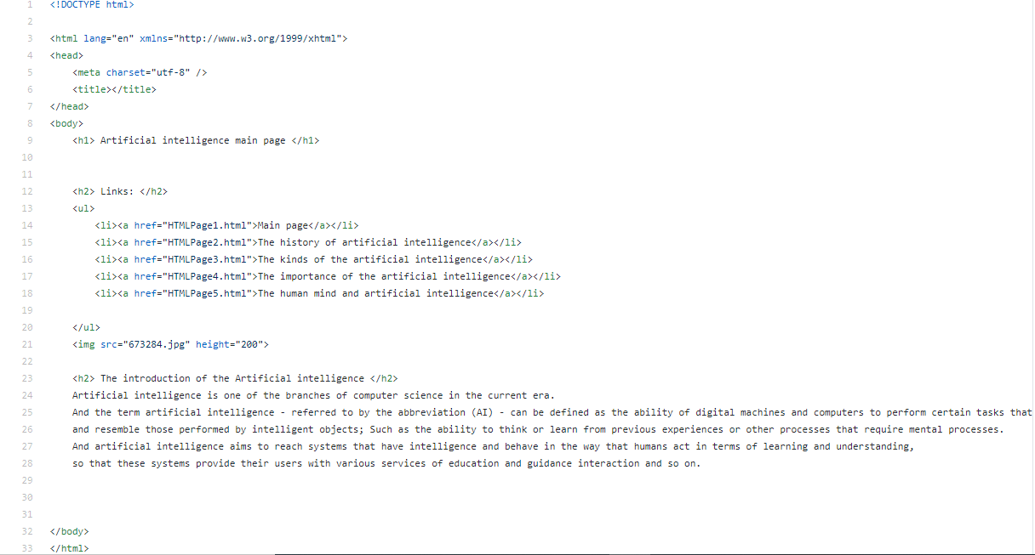

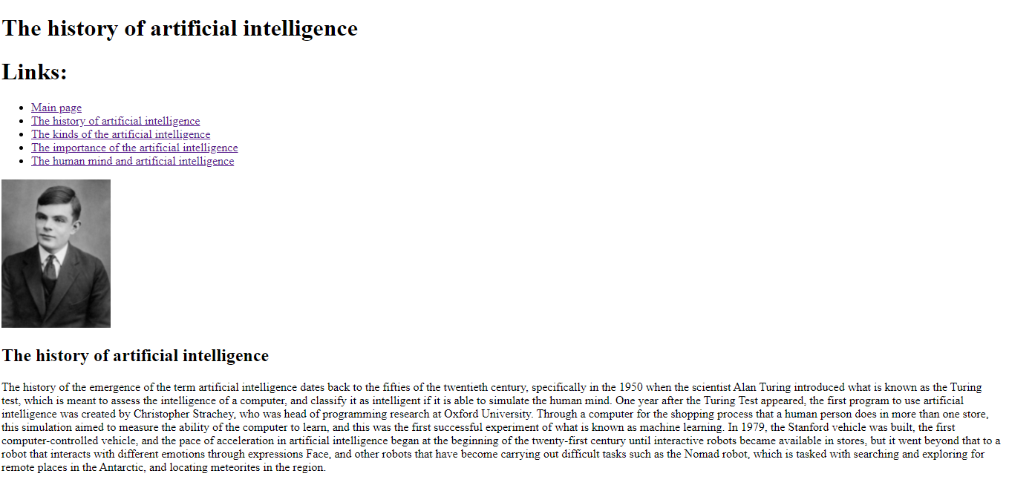

And this code is

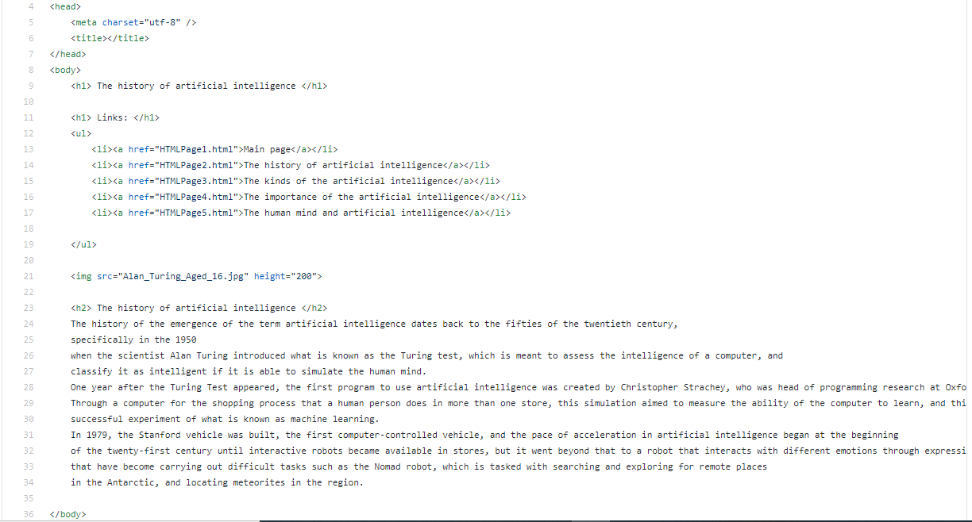

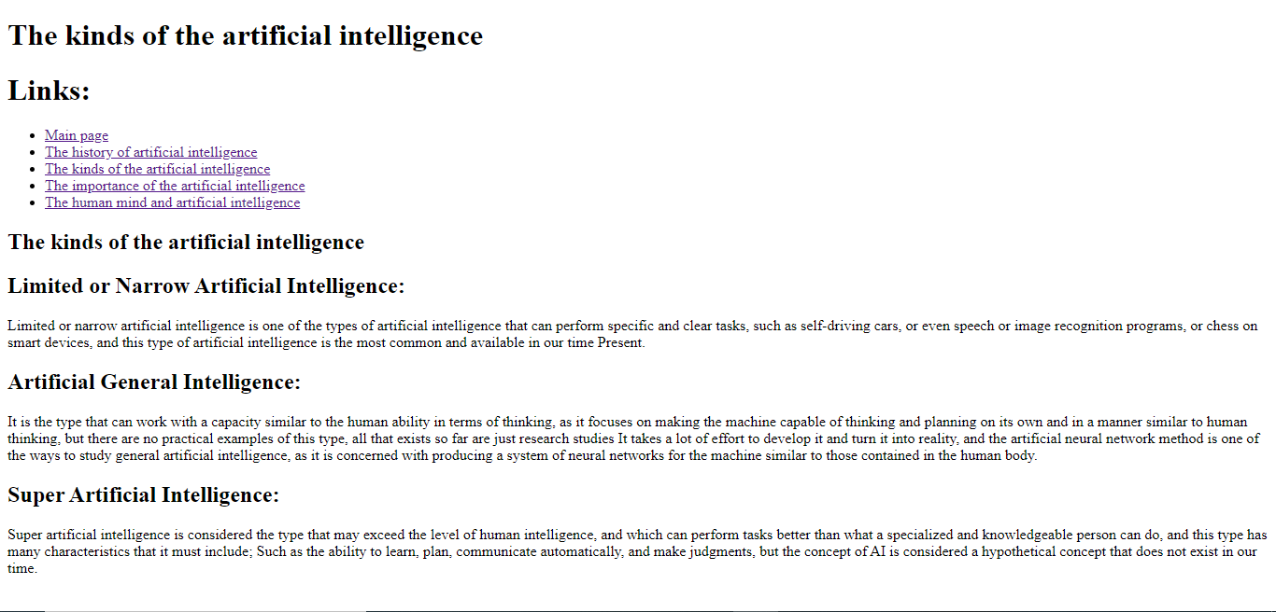

And this code is

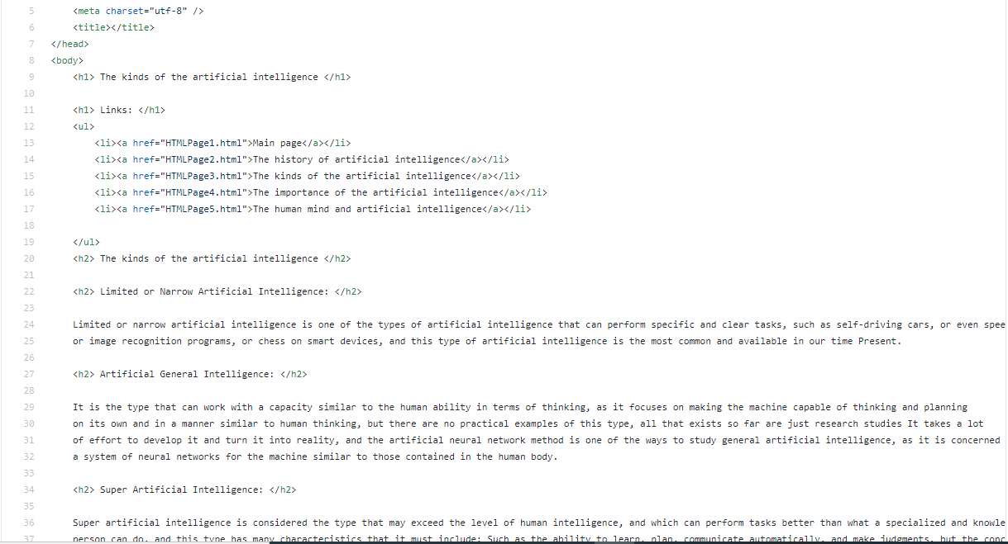

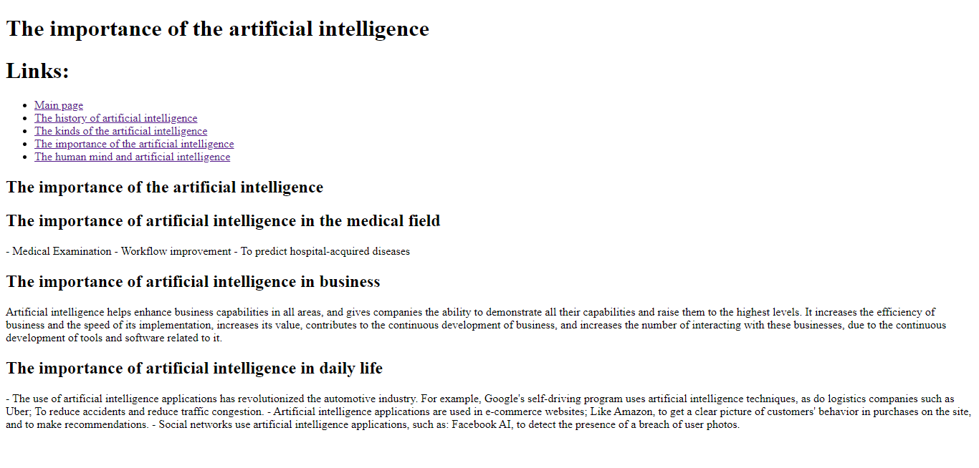

And this code is

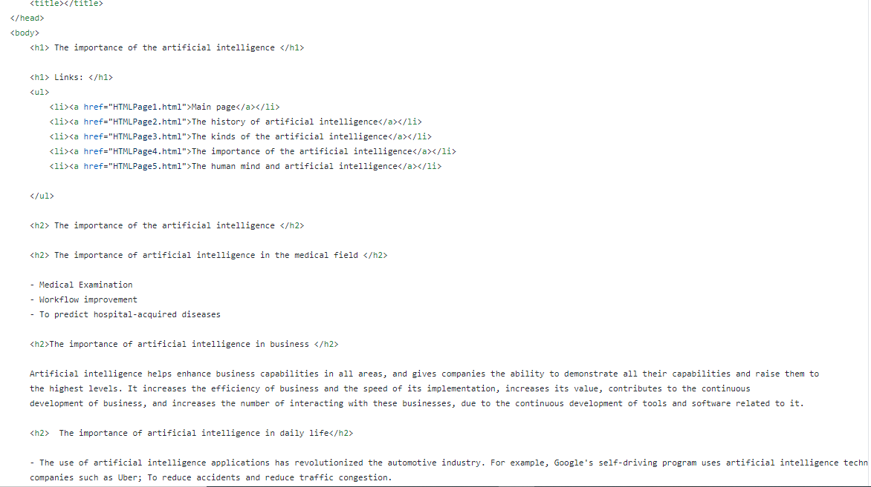

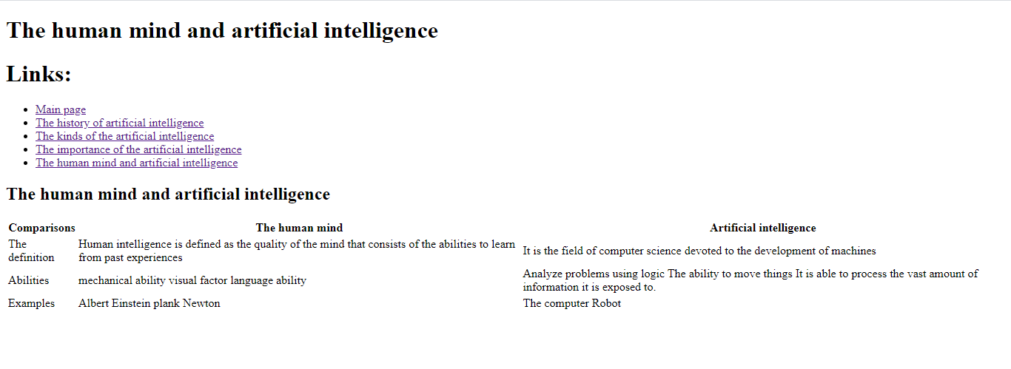

And this code

